Yu-Gi-Oh! TCG History Progression Series
Custom Card Addition Process
Objective: In order to reflect separate printings with different rarities and artworks in the Dungeon Duel Monsters Yu-Gi-Oh! TCG History Progression Series, each printing of a card needs to be its own custom card in the campaign. This is done by creating an entry in the custom.json. The pack lists in the pack.json also need to be updated to use the custom card for that printing. In the settings.json, there is a rarity block where the custom card needs to be added to the appropriate rarity list in order for the appropriate rarity foil effect to be applied. Finally, also in the settings.json, the custom card needs to be added to the appropriate rarity tag block so that events can identify that card by its rarity. All work should be tested in the Dungeon Duel Monsters application to verify that the json is correctly formatted prior to being pushed to the GitHub repo. Each step will be outlined with example below.

Identify the Set and Relevant Resources
Details for each Yu-Gi-Oh! TCG set should be easy to find online if you know where and how to look.
List of all TCG set releases: https://yugioh.fandom.com/wiki/Order_of_Set_Release#TCG-EN
Find set lists with rarities on the set’s fandom page (example, can be found in above link): https://yugioh.fandom.com/wiki/Legend_of_Blue_Eyes_White_Dragon
Set Code: Take note of the set’s 3 character set code on the set’s fandom page (ie LOB for Legend of Blue Eyes White Dragon)
Dungeon Duel Monsters application (where to test the jsons; app download is on itch.io): https://dungeonduelmonsters.com/
Campaign GitHub: https://github.com/MichaelBuxbaum/DungeonDuelMonsters-TCGHistoryProgressionSeries.git
Communicate: Let me know what you are working on so we don’t accidently duplicate work

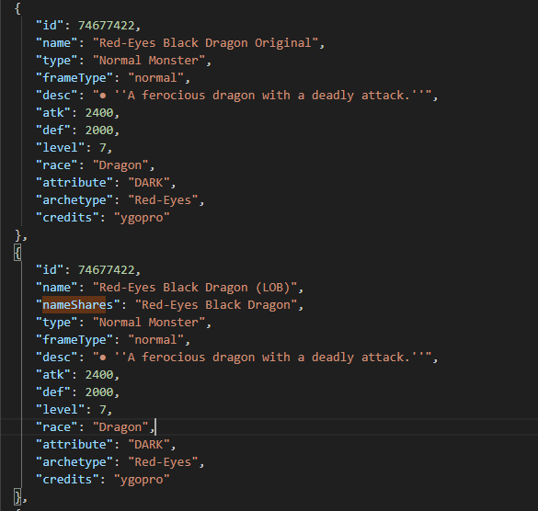
Create a Custom.json Entry
Once you know what set you are working on and have its card list, its time to actually create the cards in the custom.json. This json is already loaded with the entire yugioh tcg database, so you can ctrl+f your way around and copy past the original card’s block with minor changes.

The changes you will need to make to each copy include:
- Name: The name should be the same as the original except with the set code include in parenthesis at the end of the name
- nameShares: Each custom card needs the attribute “nameShares” added immediately after the name with a value of the original monster. This attribute is how the game knows that “CardName (Set1)” and “CardName (set2)” are the same card for the purposes of deck construction limitations (otherwise you could have 3 of each printing!)
  - Note: Each original monster has “Original” included at the end of its name; do not include this
- Id: Each monster has an “id” attribute that corresponds with a card art. The picture associated with each id is determined by the ygoprodeck.com api and should usually match the desired card art. However, for certain cards with many artworks (ie Dark Magician, Blue-Eyes White Dragon, etc.) the artwork may not line up. If it does not, remove the id attribute entirely. Doing so will cause DDM to reference the /custom/ folder and try to find a .webp file with a name that matches the custom card. If you delete an id, please download the appropriate art crop (not card image) from ygoprodeck.com (https://ygoprodeck.com/card-database/), convert it to a .webp, name it the exact same as the custom card name, and add it to the /custom/ folder.

Update Pack.json
If the pack for the set you are working on does not already exist, create an entry named the same as the set code and fill out the list. Note the other packs in the file and the DDM documentation on how to do this.
- Note the rarity slot in each pack. You cannot nest rarity odds, so in order to emulate a single slot where multiple rarities can be found, all rarities that can be found in that pack slot have to be grouped together and their odds must be emulated by customizing the quantity of each card in the pack pool (the number after the colon after each card name)
- Cards being included in the rarity slot in a pack has no technical affiliation with the rarity foil effect or the rarity tag value that card will have; all 3 of these concepts are independent from one another

If your pack does already have an entry, update each card name to be the new custom card name (usually this should just be adding the set code to the end).

Apply the Rarity Foiling
For cards of any rarity that is not common, they should have a visual “foil” effect applied to visually denote their rarity. Each rarity effect is a .webp file in the /pack/ folder and the name of the rarity exactly matches the name of the rarity in the rarity block of settings.json. You should not modify the rarity image or rarity name in settings.json.
To apply the appropriate rarities, identify the rarity block that corresponds with your custom card’s rarity in the pack you are working on and include the custom card’s name (CustomCard (Set)) in the list of cards in the set. Note that this is one big list – in order to make navigation manageable, I am separating the cards from each set with a blank row. Note that these rares are in order of product release (not just set release). You can find a list of all the products in EventTimeline.txt in the /junk/ folder.
Please replace or add the cards for your set to the appropriate sets and then move on to the final step.

Add the Rarity Tag
For each card to be filtered programmatically, it needs to have a tag associated with it to filter on. These tags are defined in settings.json and like rarities, they are just a big list of card names… Please find the appropriate rarity and update one more list with the card name… -_-

Pull Request
Before creating a pull request, please pull latest from the repo so you have the latest updates. Create a pull request and I will review/test/accept your changes. Basic development practices apply…

